**Templated CARD surveys for patients and caregivers**

**This document contains three surveys as described below. These documents can be found at CardSystem.ca.**

* **Tell us how you feel!  
  For individuals aged 8 years and older 2**

Patient symptom and feedback survey. Suitable for individuals aged 8 years and older undergoing medical procedures involving needles.

Provide to patients after the procedure. Use feedback to inform interactions and future practice.

* **Tell us how you feel!  
  For individuals aged 5-7 years 4**

Patient symptom and feedback survey. Suitable for individuals aged 5-7 years undergoing medical procedures involving needles.

Provide to children and parents/guardians after the procedure. Children can be assisted by parents/guardians or staff when completing it. Use feedback to inform interactions and future practice.

* **Tell us how you feel!  
  For parents/guardians and caregivers 6**

Parent/guardian and caregiver symptom and feedback survey: For parents/guardians of children undergoing medical procedures involving needles.

Provide to parent/guardian and caregivers after the procedure. Use feedback to inform interactions and future practice.

Tell us about what happened so we can help to make needles a better experience for you if you ever need to get another needle. It’s OK if you don’t know or don’t want to answer the questions.

1. Tell us how much the needle hurt.   
   Pick a number from 0 to 10, where 0 is no pain at all and 10 is the most pain possible.

0  1  2  3  4  5  6  7  8  9  10

1. Tell us how scared or worried you were about the needle.   
   Pick a number from 0 to 10, where 0 is not scared or worried at all and 10 is the most scared or worried possible.

0  1  2  3  4  5  6  7  8  9  10

1. Tell us how dizzy you were before, during and after the needle.   
   Pick a number from 0 to 10, where 0 is not dizzy at all and 10 is most dizzy possible.

0  1  2  3  4  5  6  7  8  9  10  I fainted

1. We use the CARD system in our hospital. We ask people to choose what they want to do to make getting a needle easier. Tell us how much using CARD helped you with your needle today.

Not at all  A little bit  A medium amount  A lot

1. Compared to the last time you got a needle, tell us if today’s needle was better, worse or the same.

Better  The same  Worse  I don’t know  I don’t remember

1. Do you want to use CARD again if you ever get another needle?

Yes  No  I don’t know

1. Tell us about anything that helped make the needle LESS painful, scary or stressful.

1. Tell us about anything that made the needle MORE painful, scary or stressful.

**Answers to some of the following questions can be collected from the CARD checklist if completed by the child. If the questions were not answered on the CARD checklist, proceed:**

1. Did you know about CARD before coming to the hospital today?

Yes  No

1. Did you play the CARD game?

Yes  No

1. Did you know you were getting a needle today?

Yes  No

1. Some kids are afraid of needles and other kids are not. How afraid of needles are you?

Not at all  A little bit  A medium amount  A lot

1. How old are you? _____ years
2. Which of the following best describes you?  Girl  Boy  Or, I am: ______________

Tell us about what happened so we can help to make needles a better experience for you if you ever need to get another needle. It’s OK if you don’t know or don’t want to answer the questions.

1. Tell us how much the needle hurt.   
   "These faces show how much something can hurt. This face [*point to left-most face*] shows no hurt or pain. The faces show more and more hurt or pain [*point to each from left to right*] up to this one [*point to right-most face*] – it shows very much hurt or pain. Point to the face that shows how much you hurt during the needle."

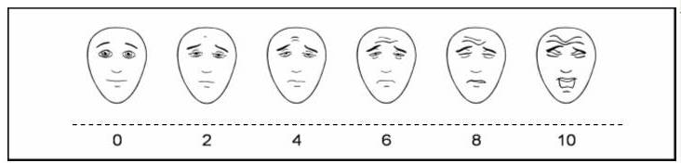

1. 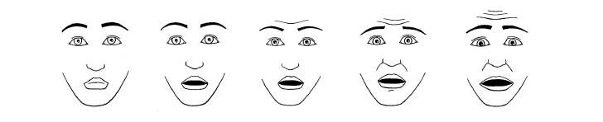Tell us how scared you were about the needle.   
   “These faces are showing different amounts of being scared. This face [*point to the left-most face*] is not scared at all, this face is a little bit more scared [*point to second face from left*], a bit more scared [*sweep finger along scale*], right up to the most scared possible [*point to the last face on the right*]. Have a look at these faces and choose the one that shows how scared you were during the needle.”
2. Tell us whether you were dizzy (shaky, wobbly).

Not at all  A little bit  A medium amount  A lot  I fainted

1. We use the CARD system here. We ask kids to choose what they want to do to help make getting a needle easier. Tell us how much using CARD helped you with your needle today.

Not at all  A little bit  A medium amount  A lot

1. Compared to the last time you got a needle, tell us if today’s needle was better, worse or the same.

Better  The same  Worse  I don’t know  I don’t remember

1. Tell us about anything that helped make the needle LESS painful, scary or stressful.

1. Tell us about anything that made the needle MORE painful, scary or stressful.

**Answers to some of the following questions can be collected from the CARD checklist if completed by the child. If the questions were not answered on the CARD checklist, proceed:**

1. Did you know about CARD before coming to the hospital today?

Yes  No

1. Did you play the CARD game?

Yes  No

1. Did you know you were getting a needle today?

Yes  No

1. Some kids are afraid of needles and other kids are not. How afraid of needles are you?

Not at all  A little bit  A medium amount  A lot

1. How old are you? _____ years
2. Which of the following best describes you?  Girl  Boy  Or, I am: ______________

Tell us about what happened so we can help to make needles a better experience for you and child in the future. It’s OK if you don’t know or want to answer the questions.

1. Relationship to child:
2. Tell us how much pain you think your child had during the needle. Pick a number from 0 to 10, where 0 is no pain and 10 is most pain possible.

0  1  2  3  4  5  6  7  8  9  10

1. Tell us how scared or worried you think your child was about the needle.   
   Pick a number from 0 to 10, where 0 is not scared or worried at all and 10 is the most scared or worried possible.

0  1  2  3  4  5  6  7  8  9  10

1. Tell us how scared or worried you were about your child’s needle. Pick a number from 0 to 10, where 0 is not scared or worried at all and 10 is the most scared or worried possible.

0  1  2  3  4  5  6  7  8  9  10

1. We use the CARD system in our hospital. We ask people to choose what they want to do to make getting a needle easier. Tell us how much CARD helped your child with their needle today.

Not at all  A little bit  A medium amount  A lot

1. Compared to the last time your child got a needle, tell us if your experience today was better,   
   worse or the same.

Better  The same  Worse  I don’t know  I don’t remember

1. Do you want to use CARD again if your child ever gets another needle?

Yes  I don’t know  No

1. Did you know about CARD before coming to the hospital today?

Yes  I don’t know

1. Did your child play the CARD game?

Yes  No

1. Tell us about anything that helped make the needle LESS painful, scary or stressful.

1. Tell us about anything that made the needle MORE painful, scary or stressful.